**Instruction:**

Complete all questions in **2 hour.**

1. Construct 4 bit Serial In parallel Out shift register using D- flip flop. Explain the Working mechanism of the circuit taking Serial input 1010. Also draw the timing diagram according to the given input.

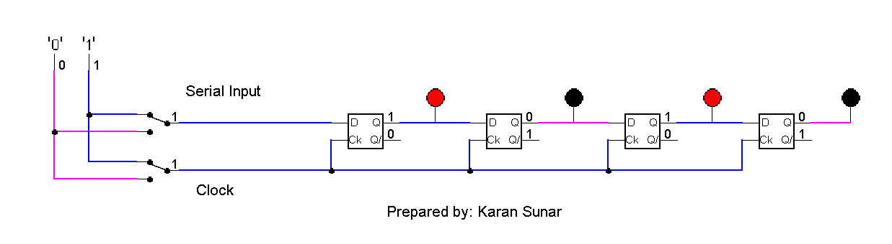

This figure shows the serial in parallel out 4-bit register using d flip flop. Whenever

the clock is 0, it doesnot store data but when clock is 1 it stores data.

| C|K | Input | Q3 | Q2 | Q1 | Q0 |
| --- | --- | --- | --- | --- | --- |
| 1 | Initally | 0 | 0 | 0 | 0 |
| 1 | 0 | 0 | 0 | 0 | 0 |
| 1 | 1 | 1 | 0 | 0 | 0 |
| 1 | 0 | 0 | 1 | 0 | 0 |
| 1 | 1 | 1 | 0 | 1 | 0 |

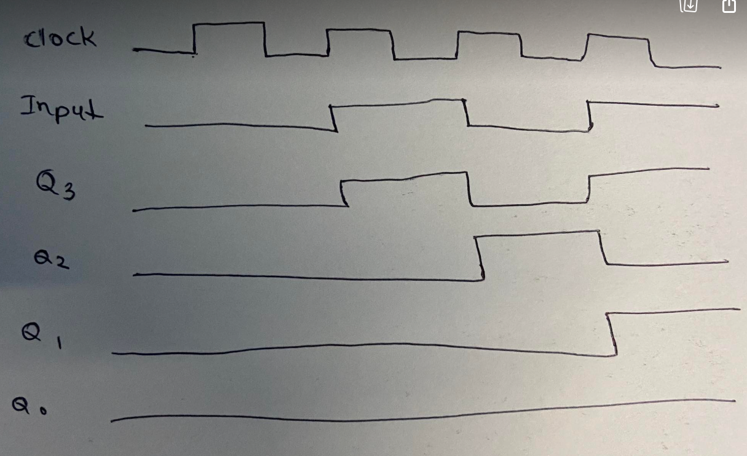

1. Design a 3 bit counter using Toggle D flip flop and draw the timing diagram.

| Q0 | Q1 | Q2 |
| --- | --- | --- |
| 0 | 0 | 0 |
| 1 | 0 | 0 |
| 0 | 1 | 0 |
| 1 | 1 | 0 |
| 0 | 0 | 1 |
| 1 | 0 | 1 |
| 0 | 1 | 1 |
| 1 | 1 | 1 |

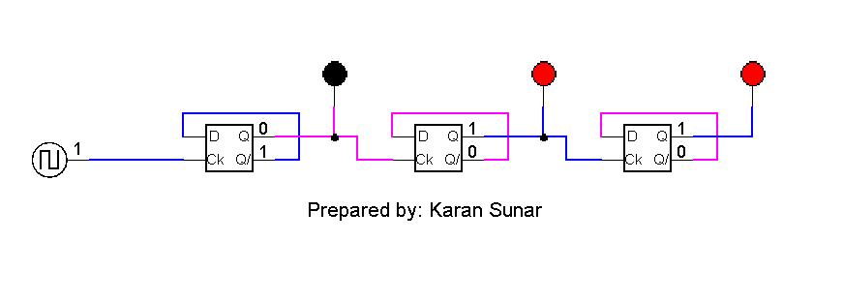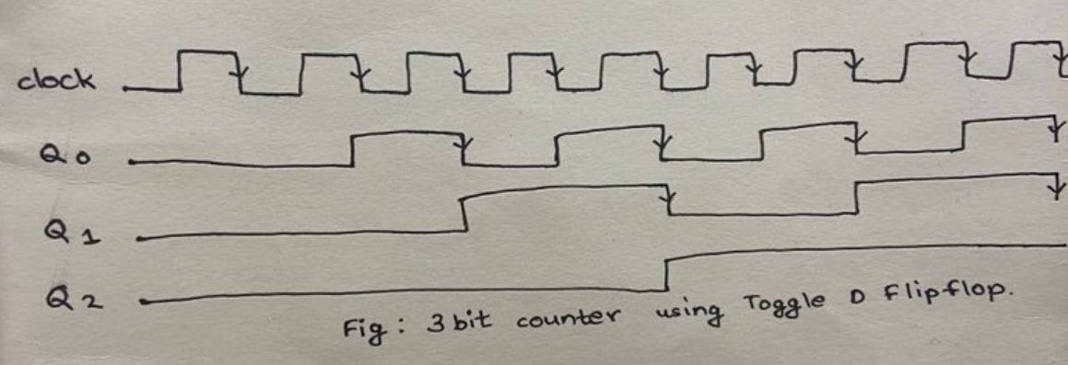

1. Load alu.cct file from the logsim folder. The circuit should look like this

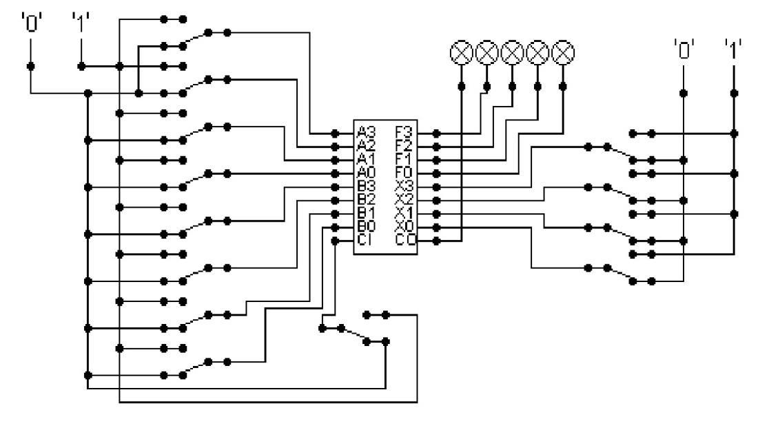

The circuit behaves like a simple arithmetic logic unit. The inputs A0-A3 represent a 4 bit binary number. Inputs B0-B3 represent another binary number. A0 and B0 are the least significant bits respectively. The following table details the functions supported by the chip. All other control lines = 0.

| Function | Add | Subtract |
| --- | --- | --- |
| X3-X0 | 1010 | 1011 |

1. Use A= 15 and B = 7

| Input A | Input B | Funaction | Result |
| --- | --- | --- | --- |
| 1111 | 0111 | 1010 (add) | 10110 |
| 1111 | 0111 | 1011  (subtract) | 01000 |

1. Use A = 13 and B = 9

Write the corresponding result of the operations. Manually provide each operation has provided the correct result.

| Input A | Input B | Funaction | Result |
| --- | --- | --- | --- |
| 1101(13) | 1001(9) | 1010 (add) | 10110 |
| 1101(13) | 1001(9) | 1011  (subtract) | 01000 |

*Thank you.*